VILLAGE OF CHASE

BYLAW NO. 734-2011

PARKS AND FACILITIES REGULATION BYLAW

A Bylaw governing the use of property held by the Village of Chase
for pleasure, recreation, or community uses.

WHEREAS the Council of the Village of Chase is empowered and authorized pursuant to the Community Charter to regulate, prohibit and impose requirements respecting public places and property within the Village of Chase; and

WHEREAS the Council of the Village of Chase deems it desirable and expedient to provide for such legislation and its enforcement.

NOW THEREFORE the Council of the Village of Chase, in the Province of British Columbia, hereby enacts as follows:

- CITATION

This Bylaw shall be cited as “Parks and Facilities Regulation Bylaw No. 734-2011”.

- REPEAL

Parks and Facilities Regulation Bylaw No. 604, 2000 and all amendments thereto are hereby repealed in their entirety.

- DEFINITIONS

In this Bylaw:

“Centennial Park” means that portion of the lands described as Lot A, Plan 16303, D.L. 517, KDYD, Except Plan M14306 as shown on Schedule “A” attached to and forming part of this Bylaw;

“Facility” includes the Community Hall and the Memorial Park Bandshell;

“Memorial Park” means that portion of the lands described as Plan B4910, D.L. 517, KDYD & Plan 10227F, D.L. 517 KDYD as shown on Schedule “B” attached to and forming part of this Bylaw;

“Mill Park” means that portion of land described as Plan B264, DL 517, KDYD as shown on Schedule “C” attached to and forming part of this Bylaw;

“Parkland” includes named Municipal Parks and other public lands that are maintained by the Village of Chase for the public’s enjoyment.

“Willson Park” means that portion of the lands described as Lot A, Plan 31877 D.L. 517 KDYD as shown on Schedule “D” attached to and forming part of this Bylaw;

“Vehicle” means a vehicle as defined in the Motor Vehicle Act:

4. PARKLANDS REGULATIONS

(1) It shall be unlawful for any person to allow a horse, under their control to enter or occupy parklands, other than those areas constructed and maintained as road surface or public parking areas unless such person has been issued authorization under Section 5 of this Bylaw.

(2) It shall be unlawful for any person to operate any motorized vehicle, including a snowmobile or motor cycle within or upon parklands, other than those areas constructed and maintained as road surface, public parking areas or areas designated and signed as motor vehicle areas unless such person has been issued an authorization under Section 5 of this Bylaw.

(3) No person shall enter or be in Centennial Park, Memorial Park, Mill Park or Willson Park between the hours of 11:00 p.m. and 6:00 a.m., or as otherwise established through signage, unless such person has been issued an authorization by the Village of Chase.

(4) No person or registered owner of a vehicle shall permit such vehicle to enter or remain in Centennial Park, Memorial Park, Mill Park or Willson Park between the hours of 11:00 p.m. and 6:00 a.m., or as otherwise established through signage, unless such person has been issued an authorization by the Village of Chase.

(5) Any vehicle unlawfully occupying a portion of parklands may be removed and impounded at owner’s expense.

(6) No fires of any kind are permitted in any parklands within the Village unless permitted by, and done so in accordance with the Outdoor Burning Regulation Bylaw.

- No person shall deposit any materials of any kind in any parklands without the written authorization of the Village of Chase.

- Dogs shall be permitted in parklands only in accordance with the Dog Control Bylaw.

- No Person shall offer for sale any goods or merchandise on Highways or in a Park within the boundaries of the Village of Chase unless they have first complied with all relevant Village Bylaws and permission by resolution of Council is granted.

5. FACILITIES REGULATIONS

- No animals except personal guide animals are permitted in the Community Hall.

- The entire Community Hall or specific rooms and areas within it may be used/rented and the Memorial Park Bandshell may also be used or rented in accordance with Schedules “E” and “F”, respectively.

6. PERMITS

(1) Upon receiving an application in the form of Schedule “E” or Schedule “F” to this Bylaw, a Permit for use of the Community Hall or Memorial Park Bandshell may be issued. Any person or persons issued a Permit must abide by all the terms and conditions of the Permit.

(2) Upon receipt of a Park Use Permit in the form of Schedule “G” to this Bylaw, a Permit for the use of a Municipal Park may be issued by Village administrative staff. Any person or persons issued a Permit must abide by all the terms and conditions of the Permit.

7. Offences and Penalties

(1) Any person who contravenes any provision of this Bylaw, or who suffers or permits any act or thing to be done in contravention of any provision of this Bylaw, or who neglects to do or refrains from doing anything required to be done by any provision of this Bylaw, commits an offence against this Bylaw and is subject to:

- a fine in accordance with the Village of Chase Municipal Ticket Information Bylaw if an information respecting the infraction is laid by means of a ticket; or

- upon summary conviction, a fine not exceeding $2,000.00 and the costs of prosecution.

8. Severability

- If any portion of this Bylaw is held to be invalid by a Court of competent jurisdiction, such invalidity does not affect the remaining portions of the Bylaw.

READ A FIRST TIME THIS 12th DAY OF APRIL, 2011

READ A SECOND TIME THIS 12th DAY OF APRIL, 2011

READ A THIRD TIME THIS 12th DAY OF APRIL, 2011

ADOPTED THIS 26th DAY OF APRIL, 2011.

________________X_________________ ______________X___________________
Mayor Corporate Officer
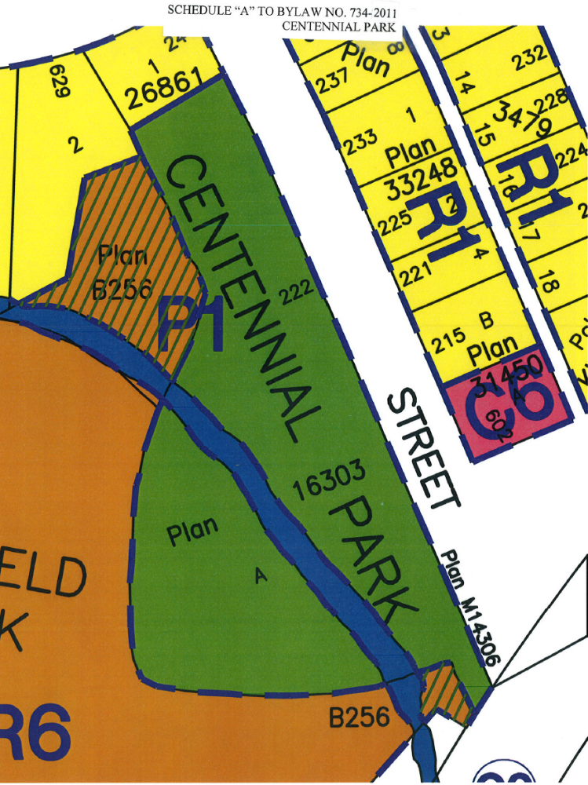
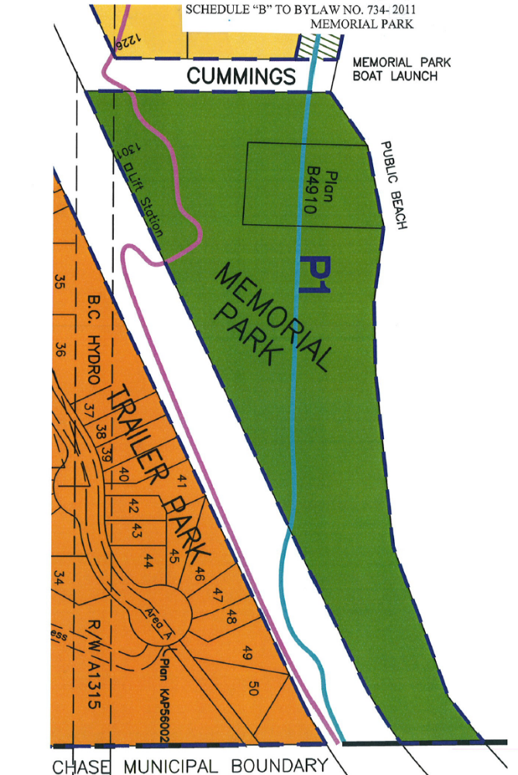
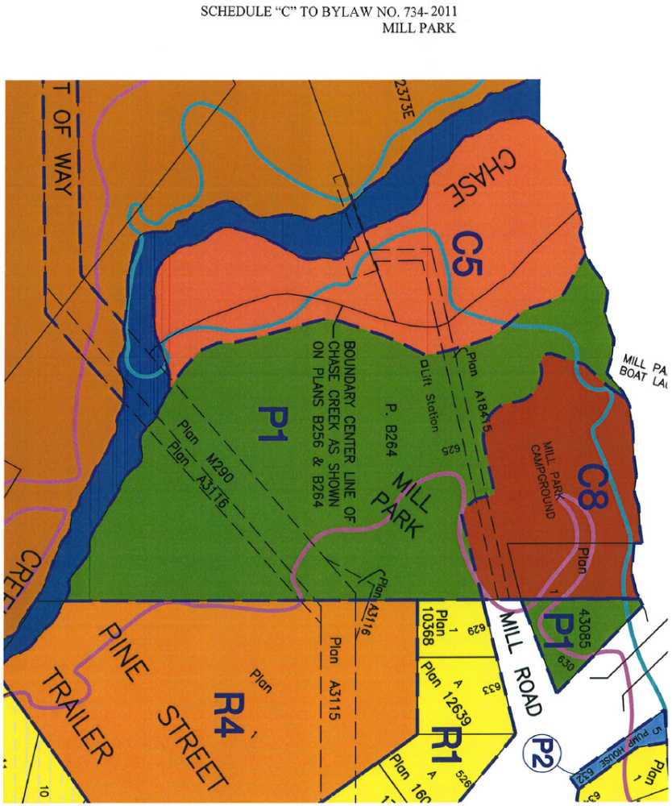
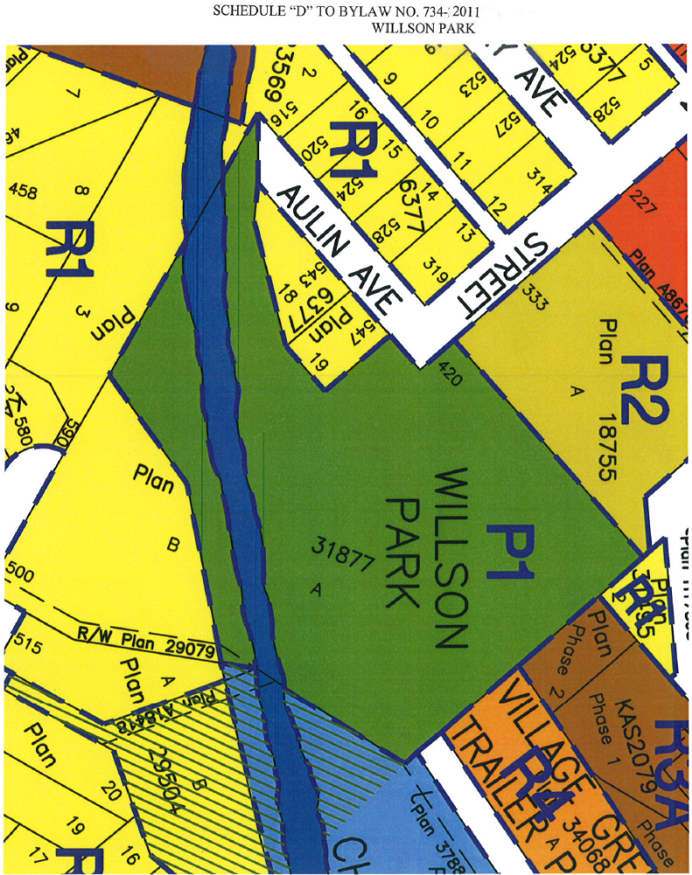
SCHEDULE “E” TO BYLAW NO. 734-2011

COMMUNITY HALL RENTAL AGREEMENT

APPLICATION DATE: __________________ RENTAL DATE(S): _______________________

DOES THE FUNCTION INCLUDE THE PROVISION OF ALCOHOL? ______ IF YES;
*A CERTIFICATE OF ALCOHOL LIQUOR LIABILITY INSURANCE MUST BE PROVIDED*

CONTACT PERSON: __________________________________________________________
(THE “RENTER”)
ADDRESS: __________________________________________________________________

TELEPHONE: ____________________________ EMAIL: ____________________________

CREDIT CARD INFORMATION:
NAME: _________________________ TYPE & NO. _________________________________

EXPIRY: _____________________________ CVC # ___________________

($200.00 SECURITY DEPOSIT FOR ALL BANQUETS/DANCES/WEDDINGS, $50.00 SECURITY DEPOSIT FOR ALL OTHER EVENTS – REFUNDABLE UPON DETERMINATION BY THE VILLAGE OF NO DAMAGE, MISSING ITEMS OR THE REQUIREMENT FOR EXTRAORDINARY CLEAN UP.)

*FACILITY FEE WAIVER - LETTER REQUIRED – SUBJECT TO COUNCIL APPROVAL*

COMMUNITY HALL:
AREAS REQUIRED: MAIN HALL ______ ROOM C ______ BAR _______ PA______ROOM A ______ ROOM B _______ KITCHEN ______
(Rental fees are in accordance with the Fees and Charges Bylaw)
TOTAL RENTAL RATE: $ ___________+ HST Paid: YES ____ NO _____

KEY DEPOSIT: $20.00 KEY NUMBER: ____________ EXTRA KEYS:___________ Paid: YES _______ NO ________ RETURNED: _______
Comments:
SECURITY DEPOSIT $ _________ Paid: YES ______ NO _______
RETURNED: ________
Comments:
P.A. DEPOSIT: $50.00 Paid: YES ________ NO _________
RETURNED: __________
Comments:
_________________________________ __________________________________
for the VILLAGE OF CHASE APPLICANT’S SIGNATURE
(permit valid only if signed by Village of Chase authorized employee)
SCHEDULE “E” TO BYLAW NO. 734-2011 (continued)
Community Hall Renters/Users Obligations

- The Renter shall be responsible for the set up and take down of all furnishings and equipment used during the Renters use of the Facility. For use of the Main Hall:
*Tables must be wiped down and stacked face to face and returned to the storage room. *Chairs must be stacked 10 high and returned to the storage room.

2. The Renter shall clean all items used and leave the Facility in the condition it was prior to function, including the packaging of all waste materials.

- Check and lock all doors prior to vacating the premises. Ensure the “bolts” are applied to front doors.

- Promptly return all keys issued for the function to the Village Office 826 Okanagan Avenue.

- The Renter shall be responsible to cover all costs associated with the repair of any damage to any Facility or appurtenances therein caused by the Renters to said Facility.

- Small, open flame (i.e. table candles) permitted only if contained within a glass/metal vessel or dish with water.

- The Renter acknowledges that the Village of Chase is hereby indemnified and shall not be held liable for injuries to persons or property resulting from the Renting of a Facility.

- The Renter shall provide evidence of liability insurance satisfactory to the Village and naming the Village of Chase on the Certificate of Insurance. If the Renter’s use of a Facility includes the provision of alcohol, the Renter must provide evidence of liability insurance for the provision of alcohol. Insurance is available locally at Chase Agencies.

- The Renter shall at all times be responsible for the conduct of persons in attendance during the Renters use of the Facility and acknowledges damage or disorderly conduct may result in denial of future rental requests.

- The Renter shall be responsible to pay any fees to any organization in connection with the playing of pre-recorded music.

- The Renter agrees to pay a $20.00 deposit for key(s) to the Community Hall. The deposit is refundable upon the return of all keys provided.

- The Renter of the Community Hall for the purposes of a banquet/dance event will provide a security deposit in the form of a credit card number and information or other form acceptable to the Village in the amount of $200.00 which will be used to pay for any damage, missing items or exceptional clean up that may be required after the event. The Caretaker and/or Village of Chase booking clerk will inspect the Facility after each event – prior to the return of any or all of the security deposit.
- Forgotten something? Contact the Village Office – Monday to Friday 8:30 am – 4:30 pm
at 250-679-3238.

Having fully read and understood the conditions of this rental agreement, the undersigned agrees to the terms and conditions herein.

____________________________________ ________________________________
Signature Print Name

____________________________________
Name of Organization

SCHEDULE “F” TO BYLAW NO. 734-2011

MEMORIAL PARK BANDSHELL RENTAL AGREEMENT

APPLICATION DATE: __________________ RENTAL DATE(S): _______________________

DOES THE FUNCTION INCLUDE THE PROVISION OF ALCOHOL? ______ IF YES;
*A CERTIFICATE OF ALCOHOL LIQUOR LIABILITY INSURANCE MUST BE PROVIDED*

CONTACT PERSON: __________________________________________________________
(THE “RENTER”)
ADDRESS: __________________________________________________________________

TELEPHONE: ____________________________ EMAIL: ____________________________

CREDIT CARD INFORMATION:
NAME: _________________________ TYPE & NO. _________________________________

EXPIRY: _____________________________ CVC # ___________________

$50.00 SECURITY DEPOSIT FOR USE OF THE BANDSHELL – REFUNDABLE UPON DETERMINATION OF NO DAMAGE OR THE REQUIREMENT FOR EXTRAORDINARY CLEAN UP.

*FACILITY FEE WAIVER - LETTER REQUIRED – SUBJECT TO COUNCIL APPROVAL*

RENTAL RATE: $ ___________+ HST Paid: YES ____ NO _____

SECURITY DEPOSIT $ _______ Paid: YES _____ NO _____ RETURNED:_______

P.A. DEPOSIT: $50.00 Paid: YES ________ NO _________
RETURNED: __________

MEMORIAL PARK BANDSHELL $50.00 KEY DEPOSIT RECEIVED ___________
RETURNED: _______
(Rental fees are in accordance with the Fees and Charges Bylaw)
HALF DAY RENTAL FEE (5 hours or less) ___________
FULL DAY RENTAL FEE (more than 5 hours) _________

_________________________________ __________________________________
for the VILLAGE OF CHASE APPLICANT’S SIGNATURE
(permit valid only if signed by Village of Chase authorized employee)

SCHEDULE “G” TO BYLAW NO. 734-2011

PARK USE PERMIT

GROUP ___________________________ ADDRESS __________________________

APPLICANT _______________________ __________________________

TEL:______________________________ __________________________

PARK _____________________________________________________________________

DATES ___________________________ TIME(S) __________________________

EVENT DESCRIPTION ______________________________________________________

SPECIAL REQUIREMENTS __________________________________________________

___________________________________________________________________________

- The permittee agrees to abide by all Bylaws in effect in the Village of Chase.
- This Permit is not transferable.
- Any temporary structures must be removed prior to the expiry date.
- This Permit is not valid unless signed by the permittee and the Village of Chase.
- The Village of Chase may cancel this Permit at any time without notice.
- The permittee hereby indemnifies and saves the Village harmless from any loss, costs or damages whatsoever arising from the privileges granted the permittee by this Permit.
- The permittee is hereby required to clean up and dispose of any rubbish, debris or other material of any kind, which is attributed to this Permit, into waste receptacle provided in the park. The Permit holder shall remove materials which cannot be placed in such receptacles. Extraordinary clean up and/or damage will be charged to the permittee at cost.
- The permittee acknowledges that all Village Parks are closed to the public between the hours of 11:00 p.m. and 6:00 a.m. and that no activity authorized by this Permit shall be conducted during these hours unless authorization is provided herein.

IN CONSIDERATION OF THE PRIVILEGES GRANTED HEREIN, I HEREBY AGREE TO OBSERVE AND ABIDE BY THE TERMS AND CONDITIONS OF THIS PERMIT AND ALL VILLAGE BYLAWS.

______________________________ __________________________________
DATE APPLICANT’S NAME (please print)

______________________________ __________________________________
Approval by the VILLAGE OF CHASE APPLICANT’S SIGNATURE

